Section A

Create Aliases Table:

CREATE TABLE Aliases

(Alias_iD Number(6),

Criminal_ID Number(6,0),

alias Varchar2(10));

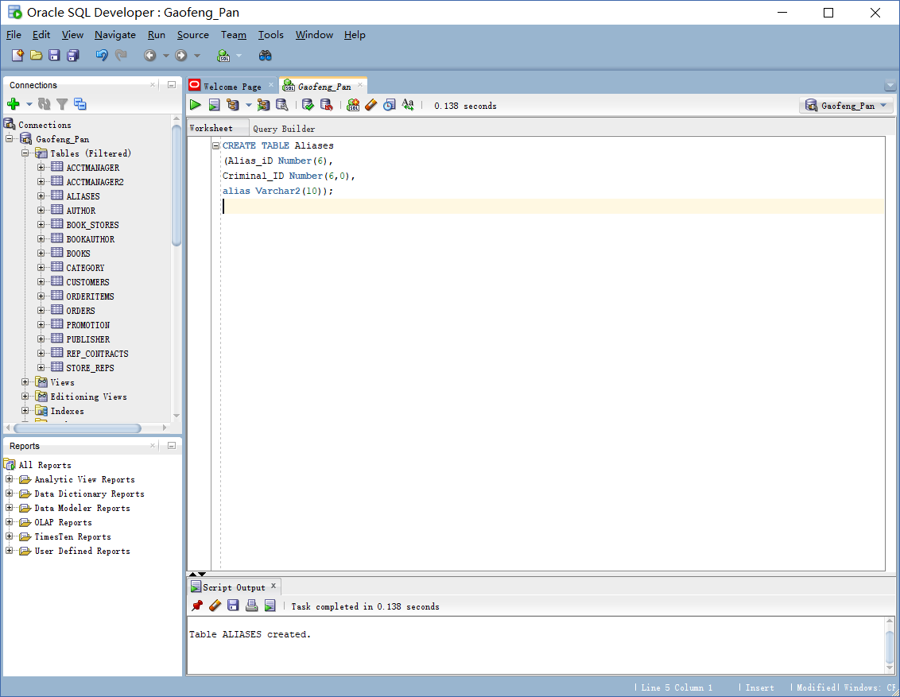

Create Criminals Table:

CREATE TABLE Criminals

(Criminal_ID Number(6,0),

Last Varchar2(15),

First Varchar2(10),

Street Varchar2(30),

City Varchar2(20),

State Char(2),

Zip Char(5),

Phone Char(10),

V_status Char(1) Default 'N',

P_status Char(1) Default 'N');

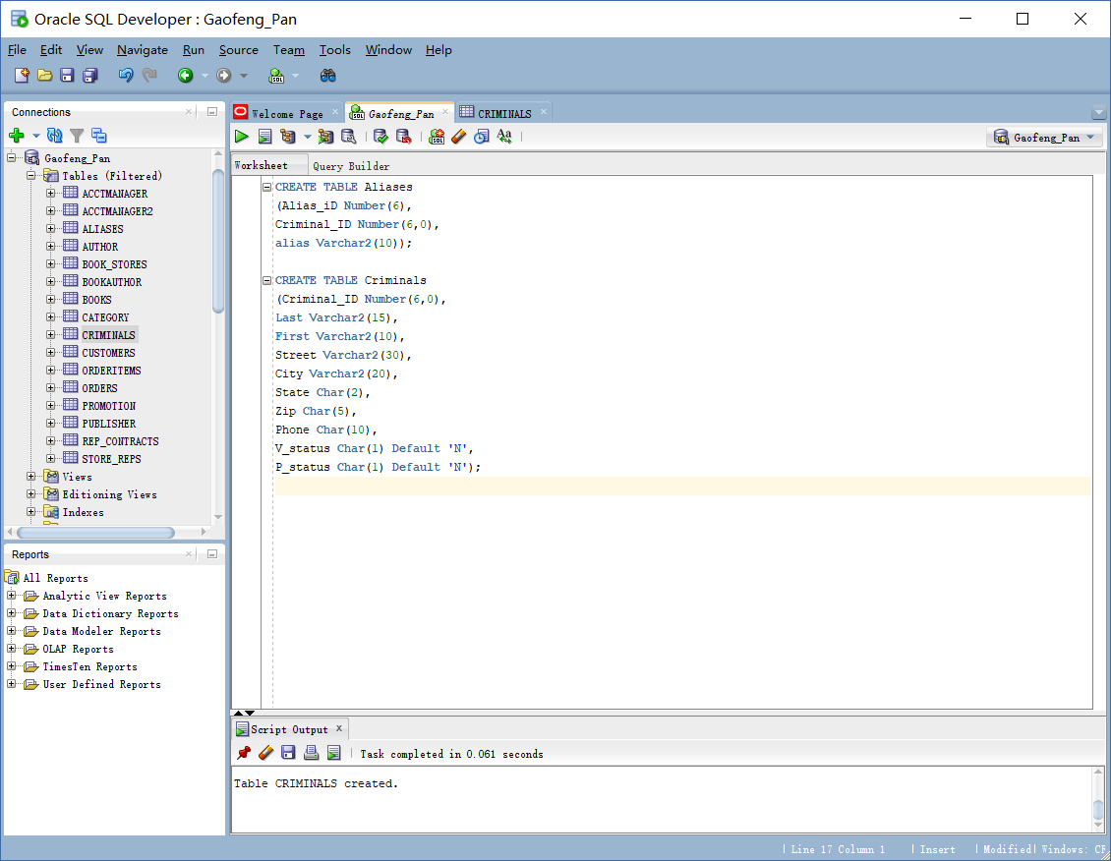

Create Crimes Table:

Create Table Crimes

(Crime_ID Number(9,0),

Criminal_ID Number(6,0),

Classification Char(1),

Data_charged DATE,

Status Char(2),

Hearing_date DATE,

Appeal_cut_date DATE);

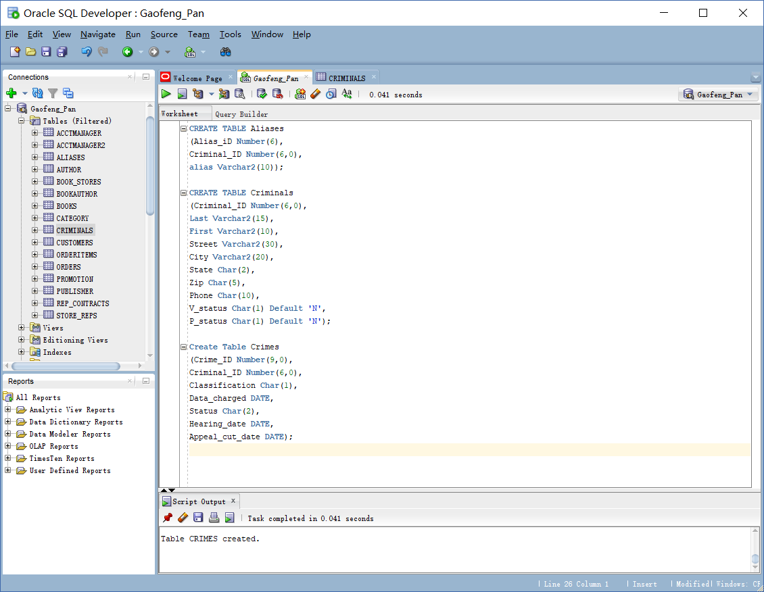

Create Sentences Table:

Create Table Sentences

(Sentence_ID Number(6),

Criminal_ID Number(6),

Type Char(1),

Prob_ID Number(5),

Start_date DATE,

End_date Date,

Violations Number(3));

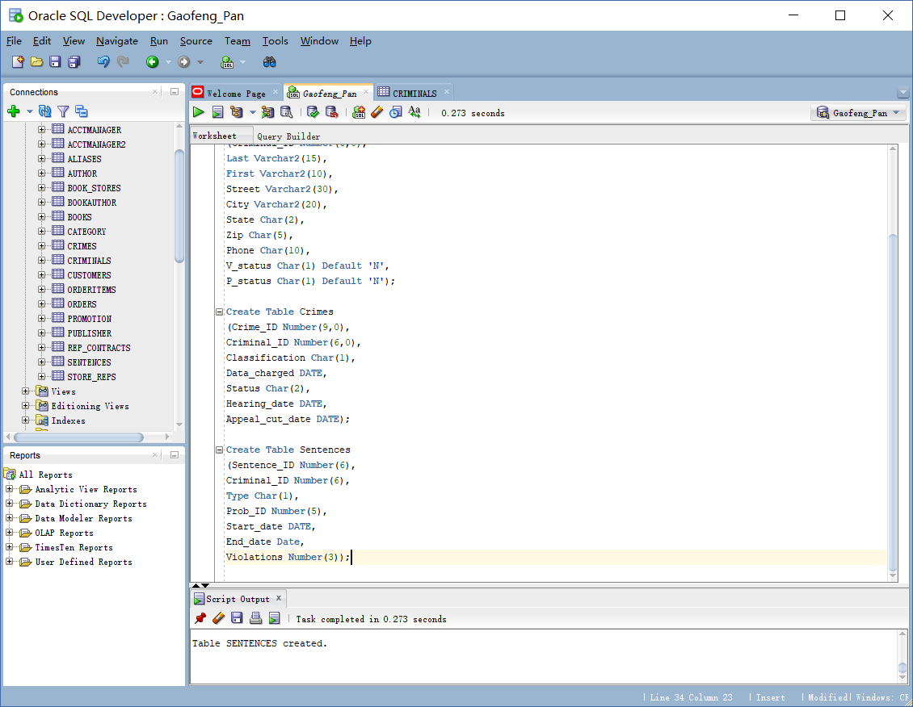

Create Prob_officers Table:

Create Table Prob_officers

(Prob_ID Number(5),

Last Varchar2(15),

First Varchar2(10),

Street Varchar2(30),

City Varchar2(20),

State Char(2),

Zip Char(5),

Phone Char(10),

Email Varchar2(30),

Status Char(1) Default'A');

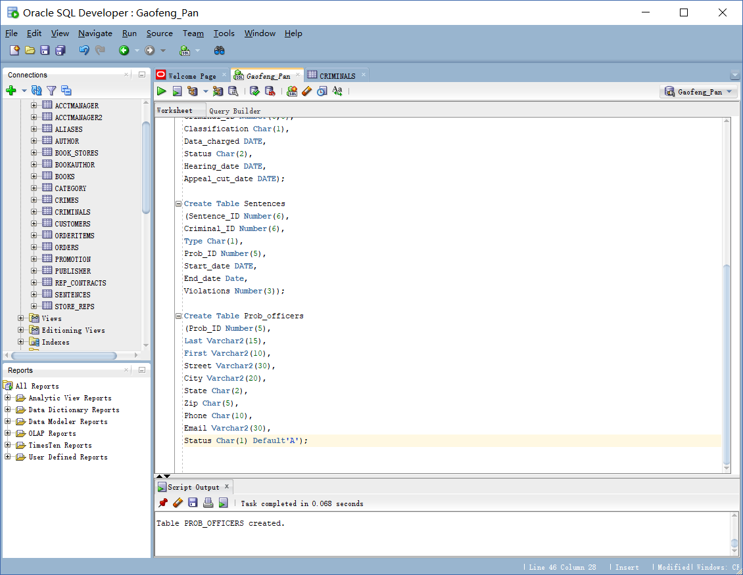

Create Crime_charges Table:

Create Table Crime_charges

(Charge_ID Number(10,0),

Crime_ID Number(9,0),

Crime_code Number(3,0),

Charge_status char(2),

Fine_amount Number(7,2),

Court_fee Number(7,2),

Amount_paid Number(7,2),

Pay_due_date Date);

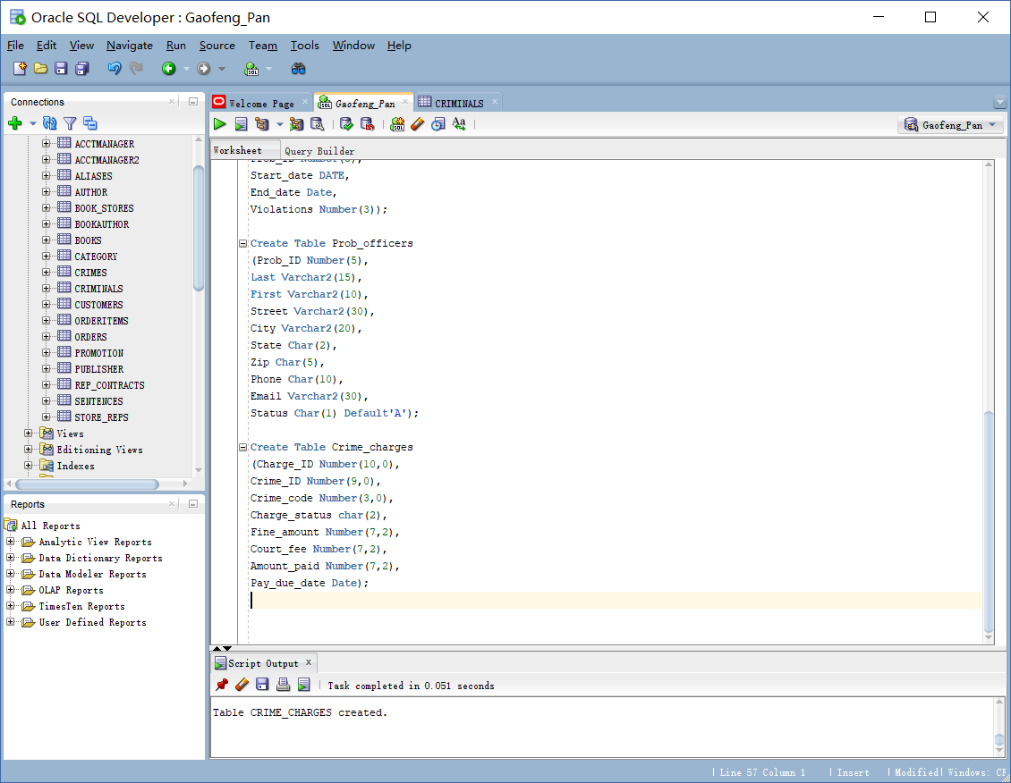

Create Crime_officers Table:

Create Table Crime_officers

(Crime_ID Number(9,0),

Officer_ID Number(8,0));

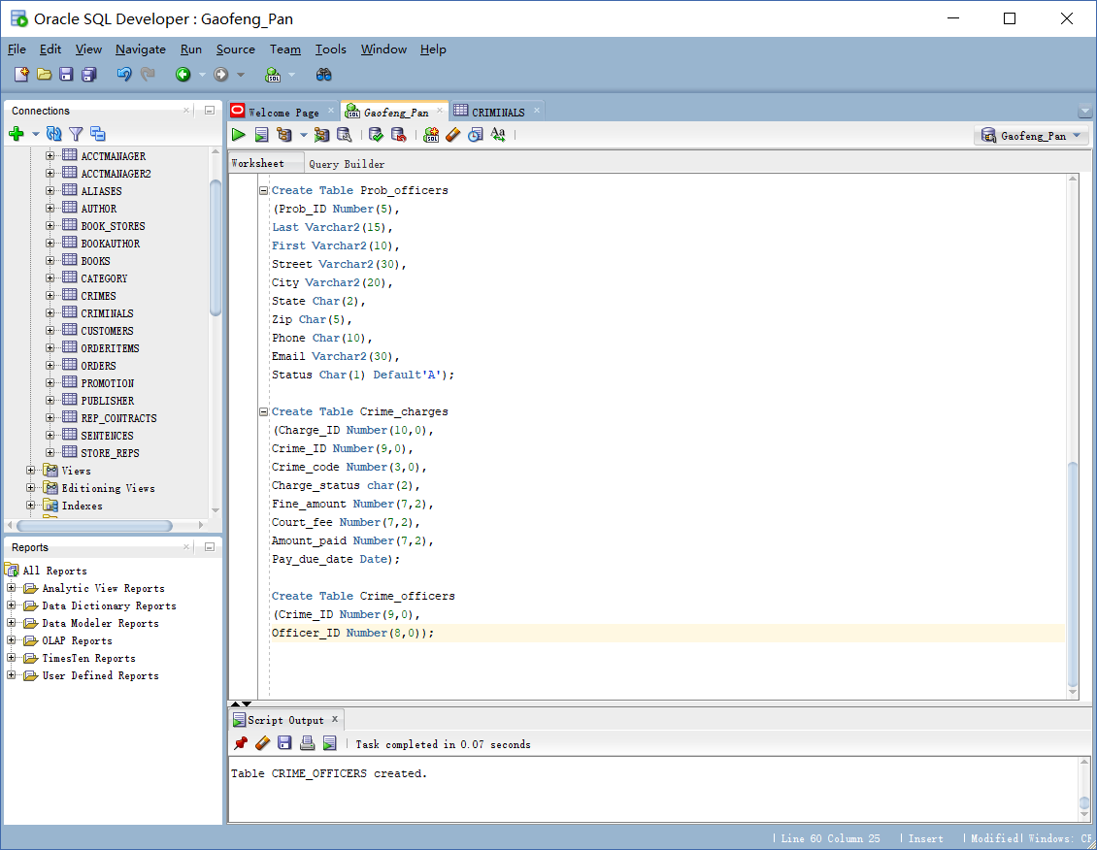

Create Officers Table:

Create Table Officers

(Officer_ID Number(8,0),

Last Varchar2(15),

First Varchar2(10),

precinct Char(4),

Badge Varchar2(14),

Phone Char(10),

Status Char(1) Default 'A');

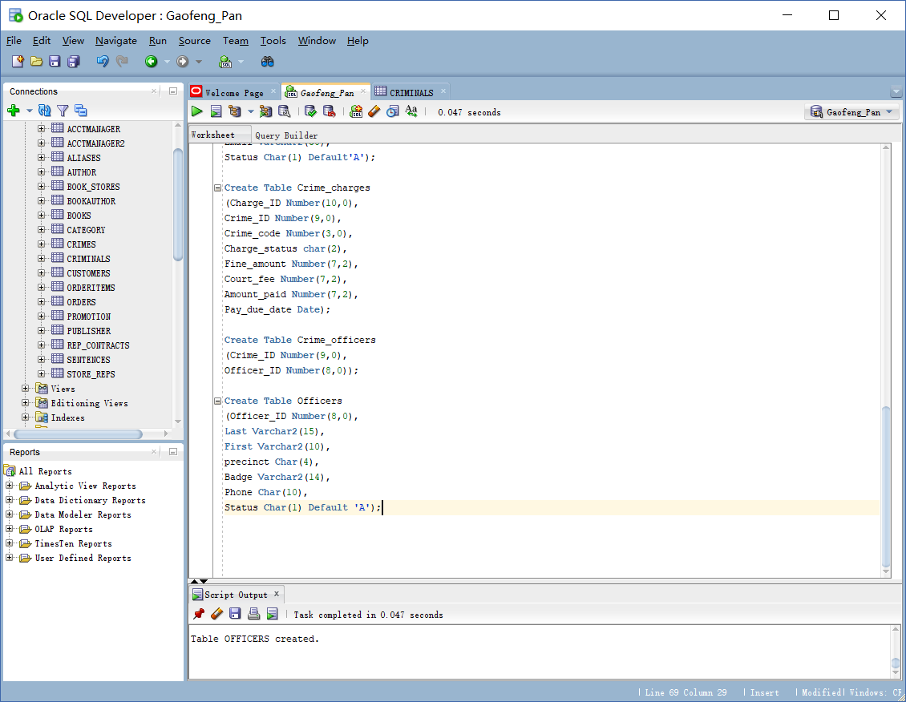

Create Appeals Table:

Create Table Appeals

(Appeal_ID Number(5),

Crime_ID Number(9,0),

Filing_date Date,

Hearing_date Date,

Status Char(1) Default 'P');

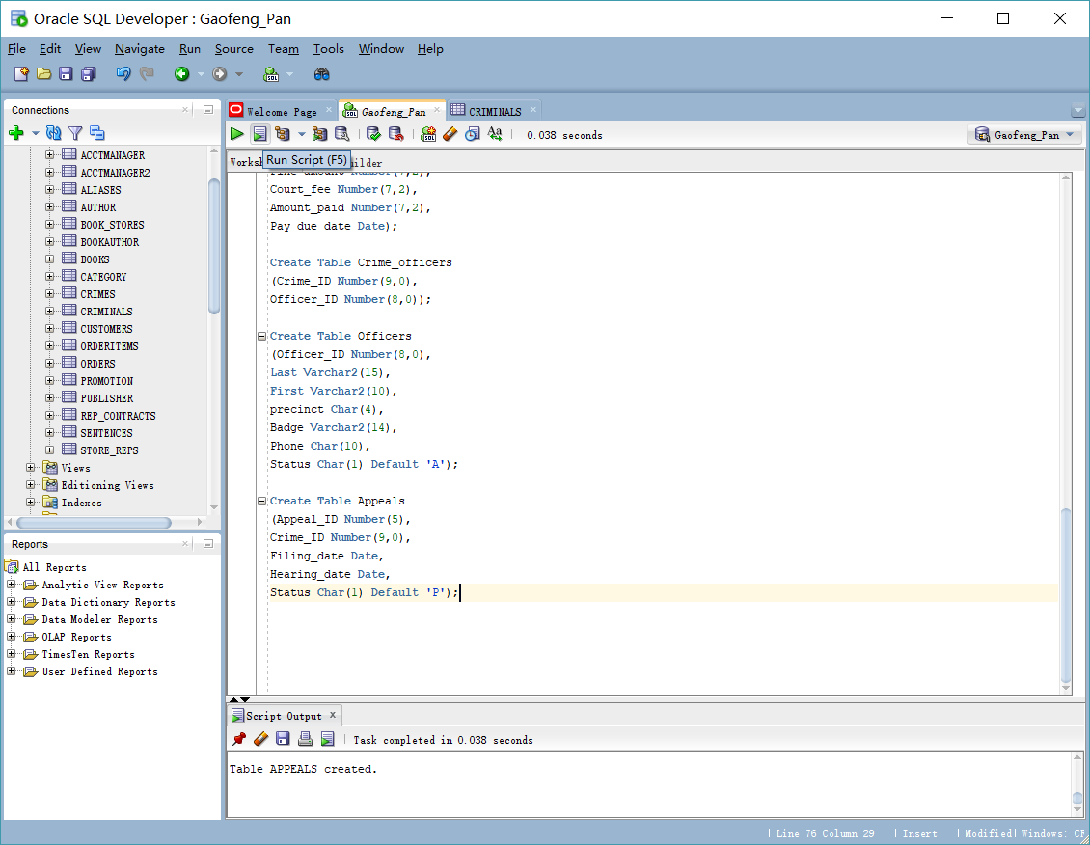

Create Crime_codes Table:

Create Table Crime_codes

(Crime_code Number(3,0),

Code_description Varchar2(30));

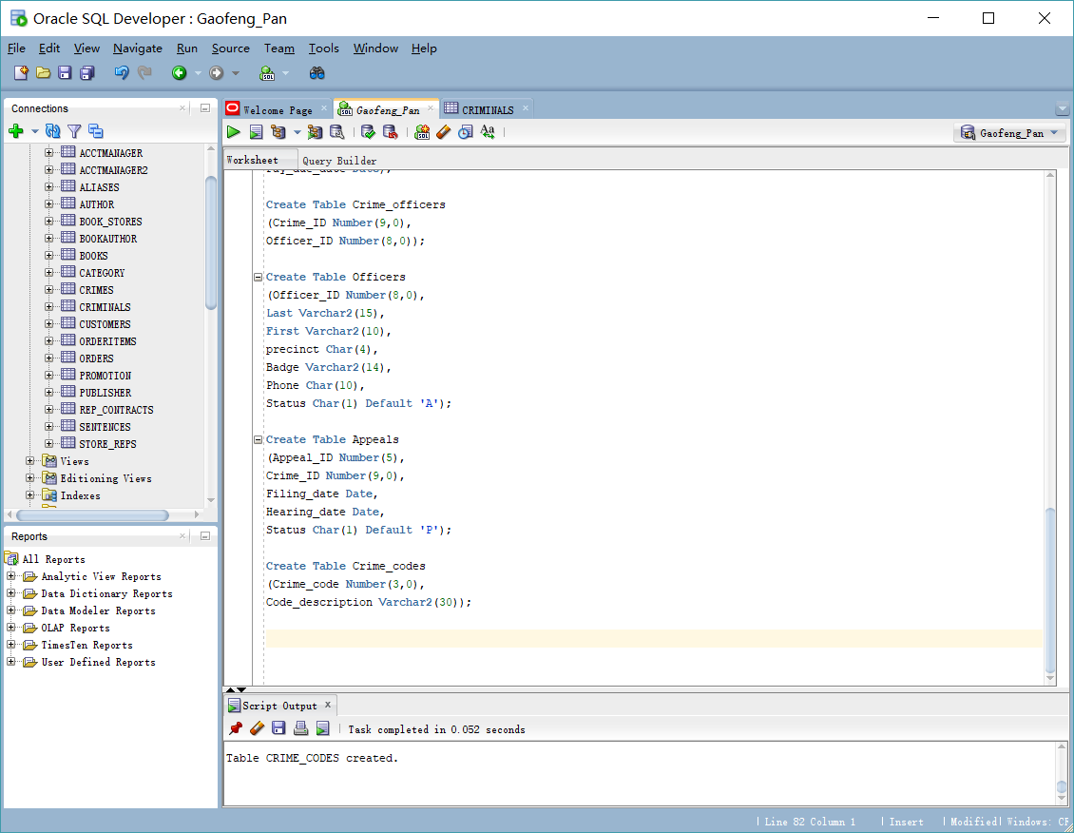

Section B

Alter Table Crimes

Modify (classification default 'U');

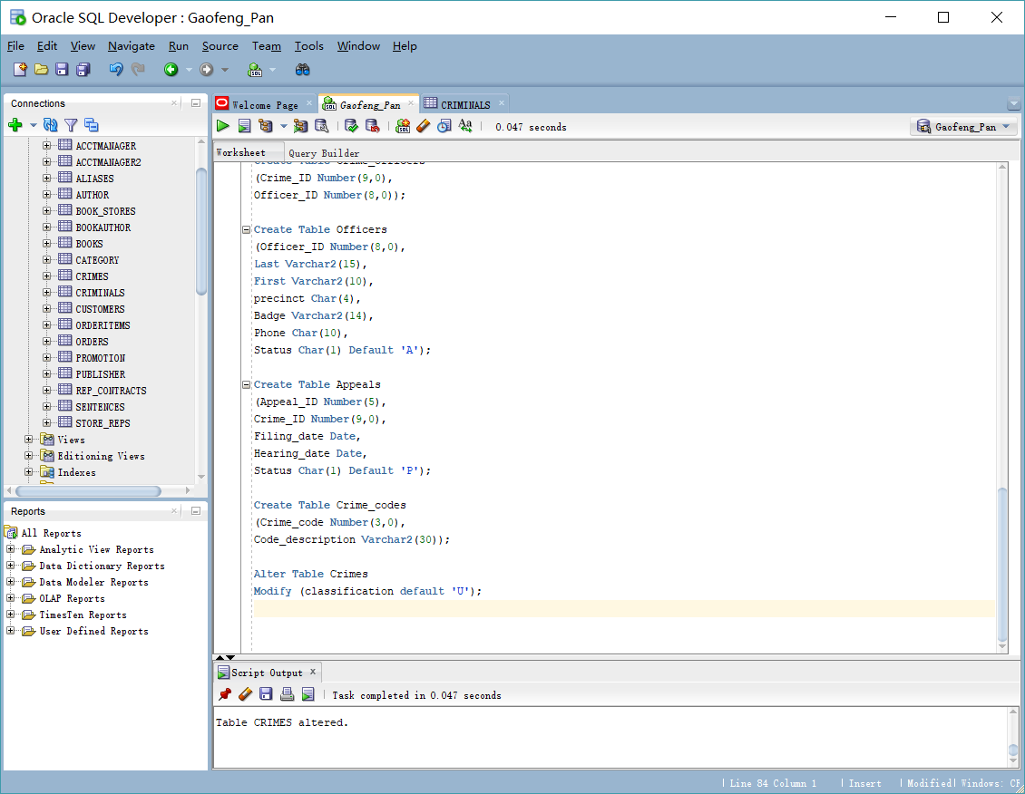

Alter Table Crimes

add (Date_Recorded Date Default sysdate);

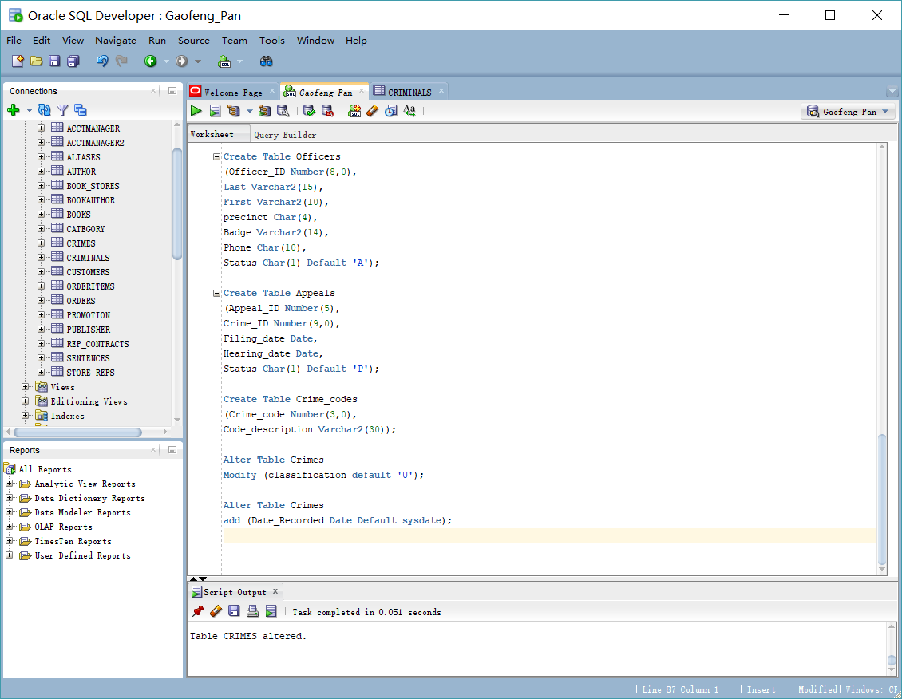

Alter Table Prob_officers

ADD (pager# Varchar2(10));

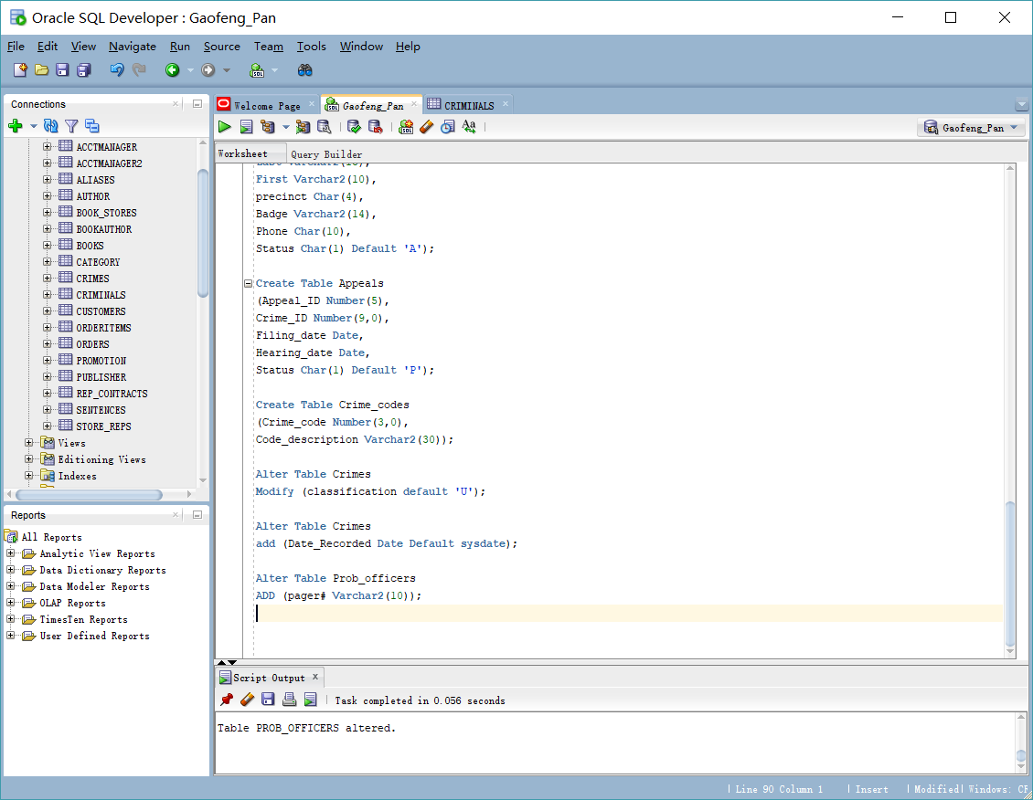

Alter Table Aliases

Modify (Alias Varchar2(20));

